Task 4 : Setup and Use a Firewall on Windows/Linux
Objective:To configure a basic host-level firewall and verify how custom rules affect incoming and outgoing network traffic. This includes enabling the firewall, adding allow/deny rules, testing connectivity, and restoring the default state.
Tools: Windows Firewall / UFW (Uncomplicated Firewall) on Linux.
Deliverables: Screenshot/configuration file showing firewall rules applied.

1.Open firewall configuration tool (Windows Firewall or terminal for UFW).
──(kali㉿kali)-[~]
└─$ sudo apt install ufw -y
ufw is installed.
┌──(kali㉿kali)-[~]
└─$ sudo ufw enable
Firewall is active and enabled on system startup
┌──(kali㉿kali)-[~]
└─$ sudo ufw status
Status: active
2.List current firewall rules.
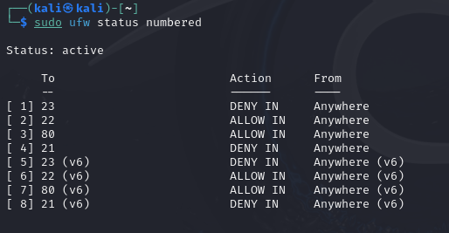
3.Add a rule to block inbound traffic on a specific port (e.g., 23 for Telnet).
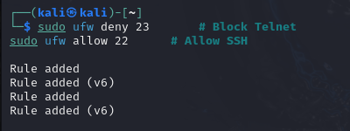
4.Test the rule by attempting to connect to that port locally or remotely.
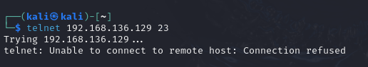
5.Add rule to allow SSH (port 22) if on Linux.
6.Remove the test block rule to restore original state.
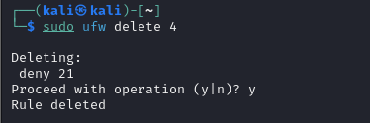
7.Document commands or GUI steps used.
Step | Command
Enable firewall | sudo ufw enable
View rules | sudo ufw status numbered
Block port 23 | sudo ufw deny 23
Allow SSH | sudo ufw allow 22
Remove rule | sudo ufw delete <rule-number>

Summary: How Firewall Traffic Filtering Works
A firewall inspects and controls network traffic based on predefined policies.
It filters packets using several parameters:

Ports: identifies services (e.g., 22–SSH, 80–HTTP)
IP Addresses: allows/block specific hosts or networks
Protocols: such as TCP, UDP, ICMP
Direction: incoming (ingress) or outgoing (egress)

Why Firewalls Are Important
- Prevent unauthorized access
- Reduce exposure to risky services (e.g., Telnet, FTP)
- Protect against network scanning and exploitation attempts
- Help maintain system integrity and security

